1. Open JMeter and create a new Test Plan named 'Flipkart Load Test', then add a Thread Group with 5 users and a loop count of 2.
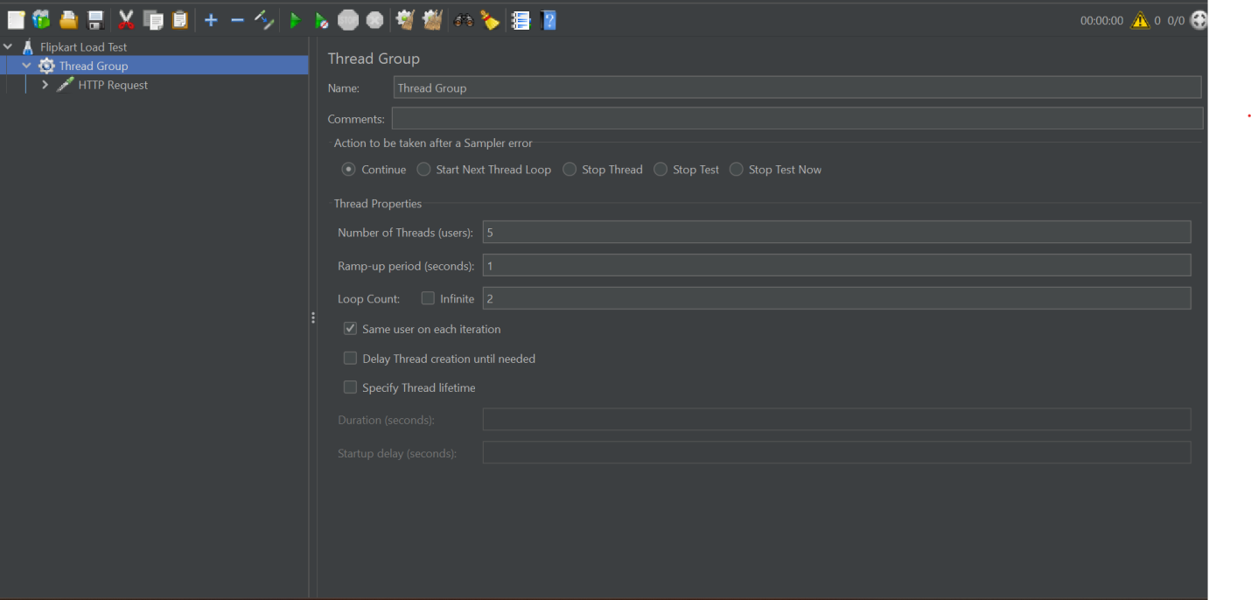

2. Inside your Thread Group, add an HTTP Request sampler to simulate a GET request to https://jsonplaceholder.typicode.com/posts and configure it to fetch all posts.
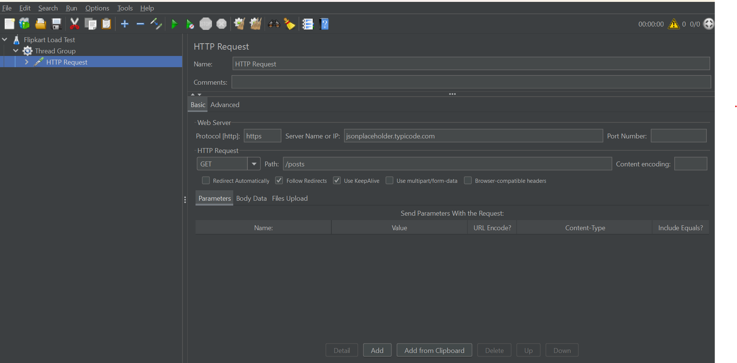

3. Add a View Results Tree listener to your Thread Group and run the test; observe and note the response time and status for each request.
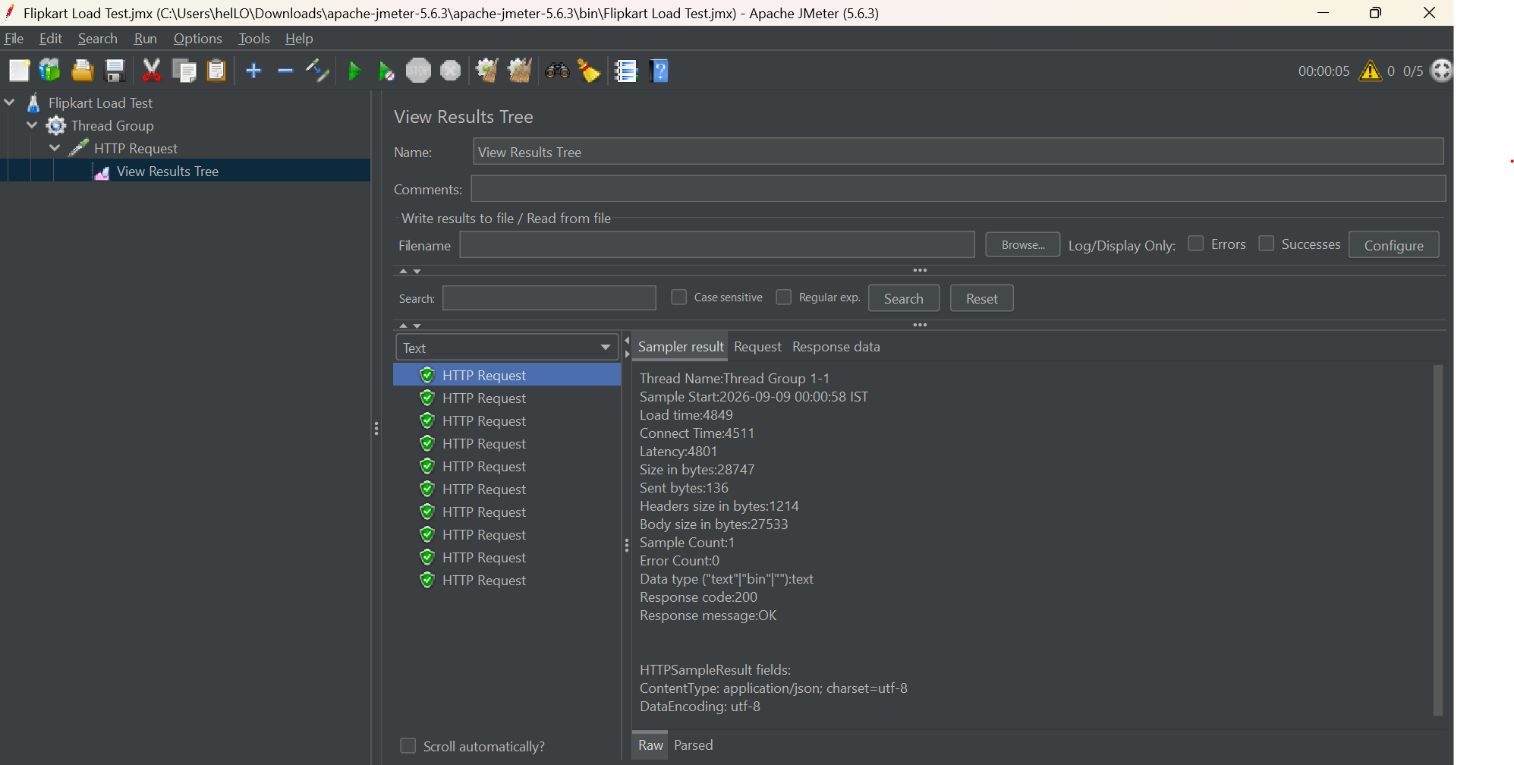
4. Add a Constant Timer to your Thread Group so that each virtual user waits 2 seconds between requests, then re-run the test and compare the results. Right-click the Thread Group, go to 'Add' > 'Timer' > 'Constant Timer'.
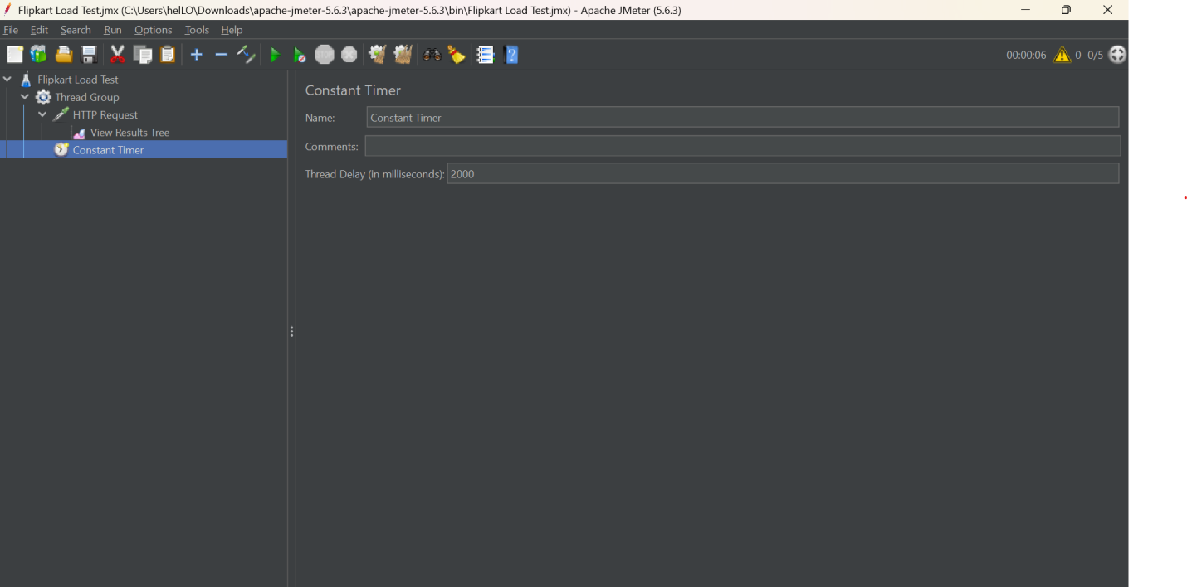

5. Enhance your test by adding a Response Assertion to check that the HTTP response code is 200 for every request. Use the 'Response Assertion' element and set 'Field to Test' as 'Response Code'.
